Thermostat Water Bath——W2L Series
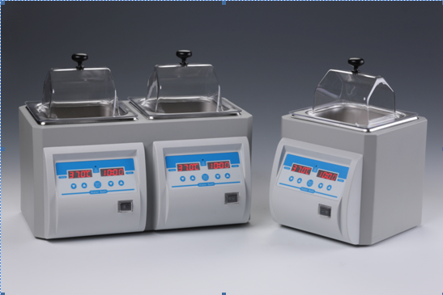

Description:
The Thermostat Water Bath is a temperature-controlled thermostat bath equipment. This durable and dependable water bath comes with a variety of safety and convenience features. It has a unique lid design that allows condensation to drain back into the tank without spilling onto the work area. High efficiency insulation maintains temperature stability and uniformity within the bath, while keeping the housing cool to the touch.
Features:
- Digital set-up for temperature and time with independent LED display.
- Microprocessor control, uniform temperature control, high precision.
- Easy-to-clean stainless steel inner tank, with unique sealing structure to avoid water leakage.
- The side of the tank is equipped with an independent drain, which can easily drain the sewage after cleaning.
- The lid’s gabled design will divert condensation to the front and back of the tank, away from samples.
- Built-in water level detection device to prevent the danger of dry burning.
- Over-heating protection device is included.

Parameters:
Project | W2L-1 | W2L-2 | W2L-3
Temp. setting range | 0°C ∼ 100°C | 0°C ∼ 100°C | 0°C ∼ 100°C
Temp. control range | RT.+5°C ∼ 100°C | RT.+5°C ∼ 100°C | RT.+5°C ∼ 100°C
Timing range | 1min~99h59min/∞ | 1min~99h59min/∞ | 1min~99h59min/∞
Temp. accuracy | ≤±0.3°C @37°C | ≤±0.3°C @37°C | ≤±0.3°C @37°C
Display accuracy | 0.1°C | 0.1°C | 0.1°C
Temp. uniformity | ≤±0.3°C @37°C | ≤±0.3°C @37°C | ≤±0.3°C @37°C
Heating time | ≤ 30min(25°C ~100°C) | ≤ 30min(25°C ~100°C) | ≤ 30min(25°C ~100°C)
Number of tanks | 1 | 2 | 3
Tank capacity | 1x2L | 2x2L | 3x2L
Working area | 125x100x115mm | 125x100x115mmX2 | 125x100x115mmX3
Power | 300W | 600W | 900W
Voltage | AC220V or 110V/50-60Hz | AC220V or 110V/50-60Hz | AC220V or 110V/50-60Hz
Fuse | 250V 3A Ф5×20 | 250V 3A Ф5×20 | 250V 3A Ф5×20
Dimension(mm) | 206x254x310mm | 397x254x310mm | 588x254x310mm
Weight(kg) | 2.2kg | 5.5kg | 8.5kg

